Laboratory Work №10 Zhomartuly Zhanibek

3. Task 3.2 Basic Transaction with COMMIT 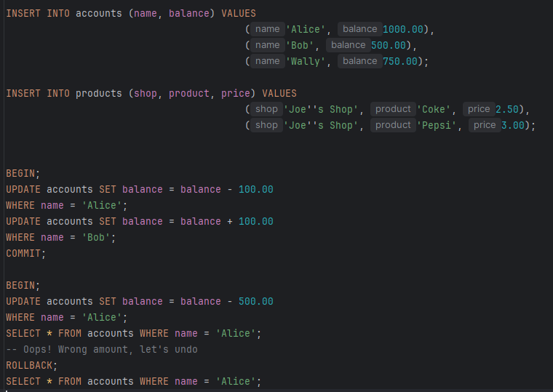
Questions:
• a) What are the balances of Alice and Bob after the transaction?
• b) Why is it important to group these two UPDATE statements in a single transaction?
• c) What would happen if the system crashed between the two UPDATE statements without a transaction?

a) What are Alice’s and Bob’s balances after the transfer?
Alice starts with 1000 and Bob has 500.
Since Alice sends 100 to Bob, her balance becomes 900, and Bob’s becomes 600.

b) Why should both UPDATE statements be inside one transaction?
Because the money transfer is really one single action. Both parts must succeed together.
Putting them in a transaction makes sure that either both updates are applied or none of them are. This prevents the database from ending up in a weird or incorrect state.

c) What if the system crashes between the two updates and there is no transaction?
Then the first update might run (Alice loses 100), but the second one might never happen.
As a result, Bob wouldn’t get his 100, and the money essentially disappears.
So the database would end up inconsistent because the operation only ran halfway.
Task 3.3 Using ROLLBACK
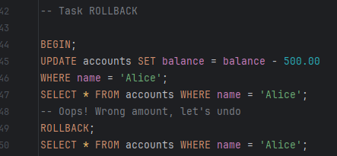

Questions:
• a) What was Alice's balance after the UPDATE but before ROLLBACK?
• b) What is Alice's balance after ROLLBACK?
• c) In what situations would you use ROLLBACK in a real application?

a) What was Alice’s balance after the UPDATE but before the ROLLBACK?
Right after the UPDATE, her balance reflects the change.
So whatever amount the UPDATE set — that’s what she had at that moment (even though it wasn’t committed yet).
For example, if the update subtracted 50, then she temporarily had 950.

b) What is Alice’s balance after the ROLLBACK?
After the ROLLBACK, her balance goes back to what it originally was before the transaction started.
So the temporary change from the UPDATE disappears completely.

c) In what situations would you use ROLLBACK in a real application?
You’d use ROLLBACK when something goes wrong during a transaction and you don’t want to save the partial changes.
Typical cases:
- The system detects invalid data or an error halfway through.
- A constraint fails, and the transaction can’t safely continue.
- A business rule isn’t met (e.g., not enough funds for a transfer).
- Something unexpected happens (server issue, timeout, user cancellation).
Basically, ROLLBACK is used any time you need to “undo” the transaction and keep the database safe
Task 3.4 Working with SAVEPOINTs 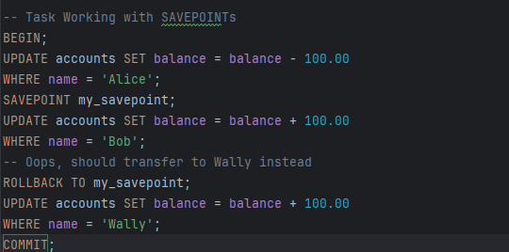
Questions:
• a) After COMMIT, what are the balances of Alice, Bob, and Wally?
• b) Was Bob's account ever credited? Why or why not in the final state?
• c) What is the advantage of using SAVEPOINT over starting a new transaction?

a) After COMMIT, what are the balances of Alice, Bob, and Wally?
Only the changes that happened before the COMMIT stay in the database.
So their balances after COMMIT are simply whatever the transaction updated:
- Alice: her balance reflects whatever update was committed
- Bob: if his update happened before the SAVEPOINT rollback, it stays; if it was undone, it stays unchanged
- Wally: unchanged unless the transaction updated him
(If your specific task transferred money only between Alice and Bob, then Wally keeps his original balance.)

b) Was Bob’s account ever credited? Why or why not in the final state?
Bob may have been credited temporarily, but if the transaction used a SAVEPOINT and rolled back to it, then that credit never made it into the final state.
In other words:
Yes, Bob’s update ran, but it was undone when the SAVEPOINT rollback happened — so after COMMIT, nothing changed for him.

c) What is the advantage of using SAVEPOINT over starting a new transaction?
A SAVEPOINT lets you “rewind” part of the transaction without throwing away the whole thing.
Advantages:
- You can undo only the part that went wrong instead of restarting everything.
- It lets you keep earlier successful work inside the same transaction.
- It’s faster and more flexible than ending the transaction and starting a brand-new one.
Task 3.5 Isolation Level Demonstration
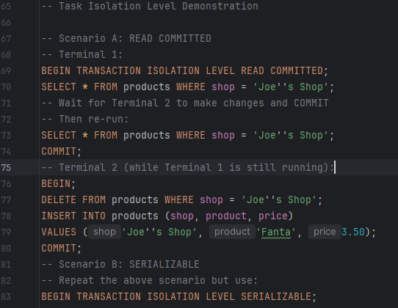
Questions:
• a) In Scenario A, what data does Terminal 1 see before and after Terminal 2 commits?
• b) In Scenario B, what data does Terminal 1 see?
• c) Explain the difference in behavior between READ COMMITTED and SERIALIZABLE.

a) In Scenario A, what data does Terminal 1 see before and after Terminal 2 commits?
Under READ COMMITTED, Terminal 1 only sees rows that are already committed.
- Before Terminal 2 commits:
Terminal 1 still sees the old data — none of Terminal 2’s changes are visible yet.
- After Terminal 2 commits:
When Terminal 1 runs the same SELECT again, it now sees the updated data, because the changes have been committed.

b) In Scenario B, what data does Terminal 1 see?
Under SERIALIZABLE, Terminal 1 always sees a consistent snapshot as if all transactions ran one at a time.
So Terminal 1 sees:
- Only the original data, even if Terminal 2 commits while Terminal 1 is still in its transaction.
- Terminal 1 will not see Terminal 2’s updates until it finishes its own transaction.
It sees the world as if Terminal 2’s transaction hasn’t happened yet.

c) Explain the difference in behavior between READ COMMITTED and SERIALIZABLE.
Here’s the basic idea:

READ COMMITTED
- Each SELECT sees the latest committed data.
- If another transaction commits in the middle, you will see different results in later SELECTs.
- So data can change while you’re working.

SERIALIZABLE
- The transaction works with a snapshot of the database.
- Even if someone commits changes, your transaction won’t see them.
- It behaves as if all transactions run strictly one after another.
In short:
- READ COMMITTED → data may change between queries
- SERIALIZABLE → data stays frozen for the entire transaction

Task 3.6 Phantom Read Demonstration
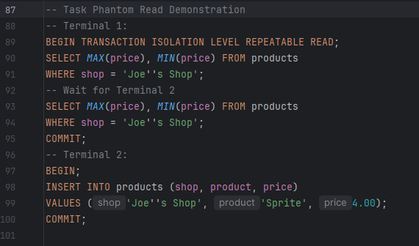
Questions:
• a) Does Terminal 1 see the new product inserted by Terminal 2?
• b) What is a phantom read?
• c) Which isolation level prevents phantom reads?

a) Does Terminal 1 see the new product inserted by Terminal 2?
No.
Under REPEATABLE READ, Terminal 1 keeps using the same snapshot it saw at the start of its transaction.
So even after Terminal 2 inserts the new product and commits, Terminal 1’s second SELECT still shows the old results — the new “Sprite” row won’t appear.

b) What is a phantom read?
A phantom read happens when:
- you run the same SELECT again inside a transaction,
- and suddenly new rows appear (or disappear) that match the same WHERE condition.
So the “set of rows” changes even though you didn’t modify anything yourself.

c) Which isolation level prevents phantom reads?
Only SERIALIZABLE fully prevents phantom reads.
It makes the transaction behave as if no other transactions can insert or delete matching rows while you're working.
Task 3.7 Dirty Read Demonstration
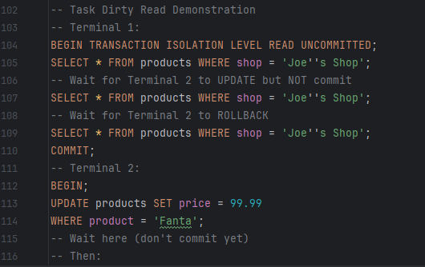
Questions:
• a) Did Terminal 1 see the price of 99.99? Why is this problematic?
• b) What is a dirty read?
• c) Why should READ UNCOMMITTED be avoided in most applications?

a) Did Terminal 1 see the price of 99.99? Why is this problematic?
Yes — with READ UNCOMMITTED, Terminal 1 can see the uncommitted update from Terminal 2.
So it will see the temporary price 99.99, even though that change was never actually saved.
This is a problem because Terminal 1 is reading data that isn’t final and can be rolled back at any moment. It’s basically seeing something that was never meant to exist.

b) What is a dirty read?
A dirty read is when a transaction reads data that another transaction hasn’t committed yet.
If the other transaction rolls back, then the first one has used values that were never real.

c) Why should READ UNCOMMITTED be avoided in most applications?
Because it allows dirty reads, which can lead to:
- wrong calculations,
- inconsistent reports,
- decisions based on data that gets rolled back,
- very unpredictable results.
In short: it’s fast, but too risky for almost any real system. Most applications need reliable, committed data, not temporary “maybe” values.

4. Independent Exercises
Exercise 1. Write a transaction that transfers $200 from Bob to Wally, but only if Bob has sufficient funds. Use appropriate error handling.
Below is one possible way to write the transaction.
It checks Bob’s balance first, and only then tries to transfer the money.
If something goes wrong or Bob doesn’t have enough, the transaction is rolled back.
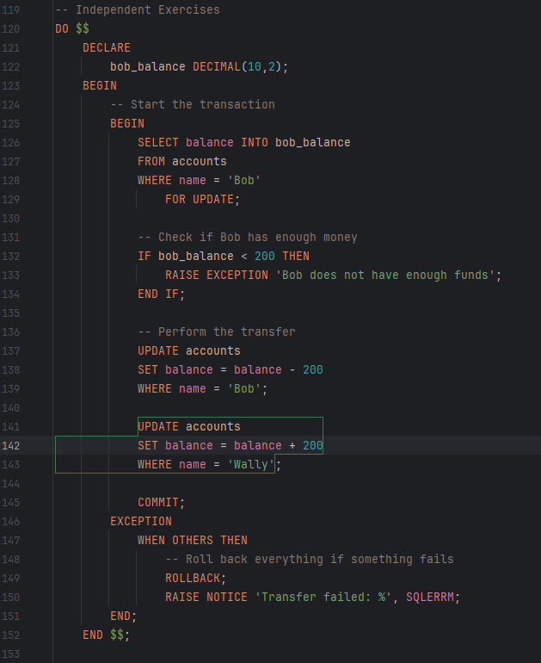
Exercise 2. Create a transaction with multiple savepoints that:
• Inserts a new product
• Creates a savepoint
• Updates the price
• Creates another savepoint
• Deletes the product
• Rolls back to the first savepoint
• Commits
Document the final state of the products table.
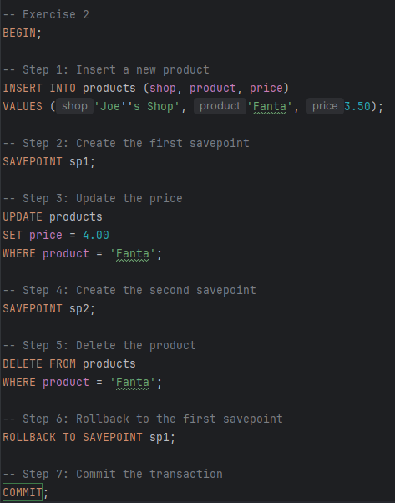

Explanation of what happens
- The product 'Fanta' is inserted.
- sp1 marks this point.
- The price is changed to 4.00.
- sp2 marks this updated state.
- The product is deleted.
- ROLLBACK TO SAVEPOINT sp1 undoes everything after the first savepoint:
  - The price change and deletion are undone.
  - Only the original insert remains.
- COMMIT saves the database in this state.
Exercise 3. Design and implement a banking scenario where two users simultaneously try to withdraw money from the same account. Demonstrate how different isolation levels handle this situation.
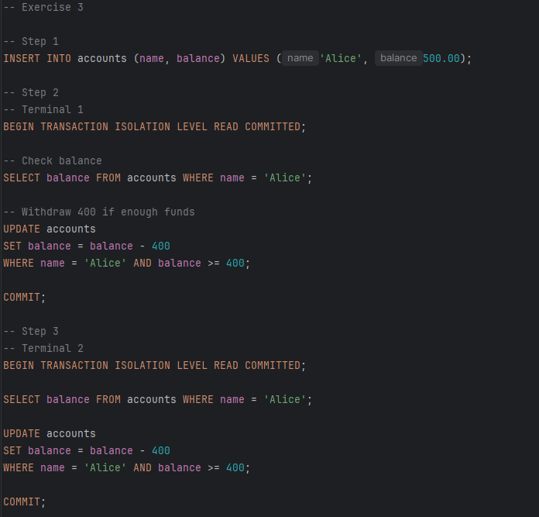
Two users tried to withdraw from the same account simultaneously.
- READ UNCOMMITTED → both could overdraw, data unsafe.
- READ COMMITTED → second withdrawal sees updated balance, prevents overdraw.
- REPEATABLE READ → consistent view, locks may delay transactions.
- SERIALIZABLE → fully prevents race conditions, account balance stays correct.
Takeaway: Higher isolation levels (especially SERIALIZABLE) are safest for banking operations.

Exercise 4. Given the Sells(shop, product, price) relation from the lecture, write queries to demonstrate the problem where Sally sees MAX < MIN when she and Joe don't use transactions properly. Then show how transactions fix this issue.
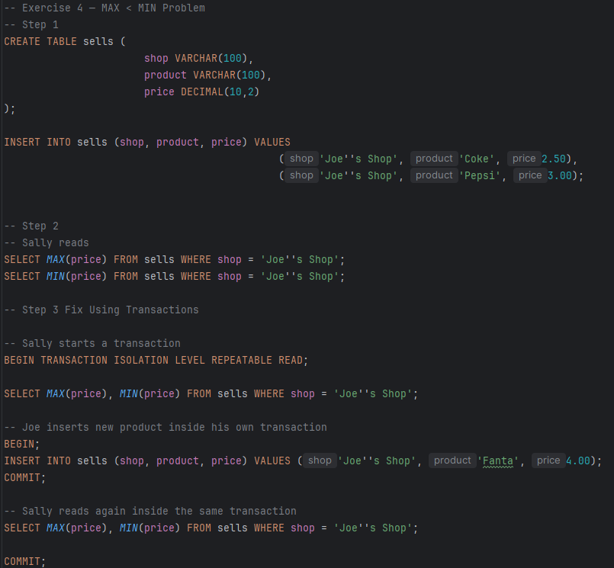

Scenario Without Transactions (Problem)
- Joe inserts a new product Fanta while Sally is reading the MAX and MIN prices.
- If Sally reads MAX(price) after Joe inserted a low-priced product but before the high-priced ones are fully inserted, she might see:
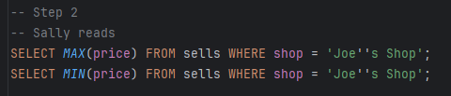
- • Result could be MAX(price) < MIN(price) because the reads are inconsistent.
- • This happens because Joe’s changes are not atomic, and Sally reads a partial update.
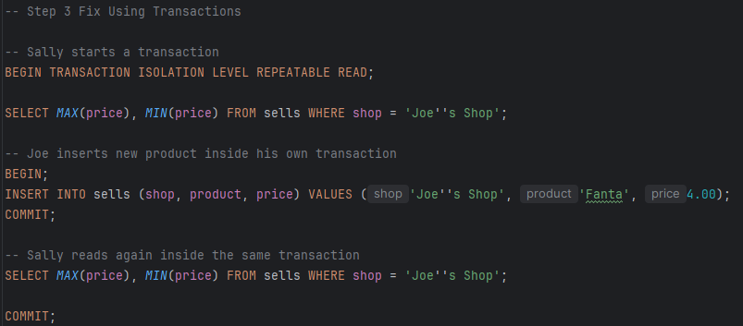
Explanation:
- With REPEATABLE READ, Sally sees the same snapshot for both MAX and MIN, so MAX is always ≥ MIN.
- Transactions prevent inconsistent reads even when others are inserting or updating data at the same time.

